**Lab Manual 7**

**Implement Static routing and Router on a Stick Inter-VLAN Routing**

|  |  |  |  |  |  |
| --- | --- | --- | --- | --- | --- |
| **Task** | **0** | **2** | **4** | **8** | **10** |
| **Create topology and apply all steps** | Student establish some connections | Student assign IP address to all devices as given in figure | Student does static routing accurately | Student assign correct gateway to each network | “Ping” command is working on all devices |

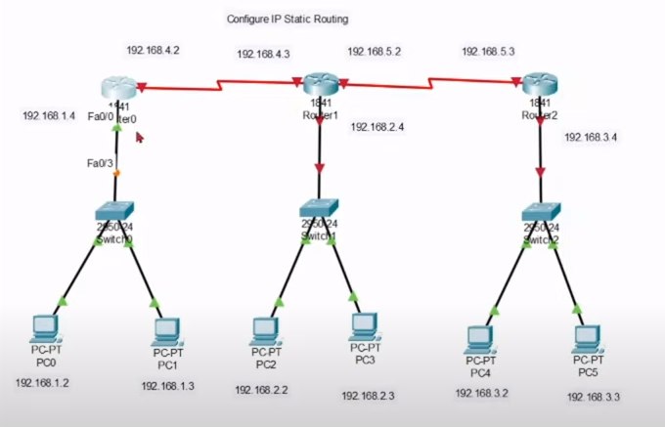

Command

*Encapsulation Dot1Q*

Use

Allows you to use a router interface as a trunk port to a switch. This is also known as “Router on a stick” because the switch uses the router to route between VLANs.

Syntax

*Router(config-subif)#encapsulation dot1Q <vlan>*

Creating sub interface in the below figure:

